Using the UV Spectrometer
Procedure
(note: Be very careful with the cuvettes – handle them ONLY by the frosted sides.)
1. Turn on the Jasco V-530 spectrophotometer. This is an example of a double beam instrument. The switch is on the lower right side.
2. Turn on the computer. Double click on the Spectra Manager icon. Double click on “Spectrum Measurement”. Allow a few minutes for the lamp to warm up and stabilize.
3. Measure background spectrum
This is due to the cuvettes themselves and the solvent. Fill two cuvettes with pure solvent. Be very careful with the cuvettes, and handle them ONLY by the frosted sides. Do not touch the clear sides with anything other than a Kim-wipe, which can be used to gently wipe the surfaces clean. The cuvettes have a path length of 1.00 cm. Place the cuvettes in the sample compartment with the clear faces facing the right and left. The front sample holder holds the sample cuvette and the rear holder will contain the pure solvent. Close the sample chamber.
Click on Measurement→Parameter. Set the following parameters:
Photometric Mode Abs.
Response Medium
Scanning Speed 100 nm/min
Start (upper wavelength of scan range, in nm, 800)
End (lower end of scan range, in nm, 300)
Data Pitch 0.2 nm (may have to change)

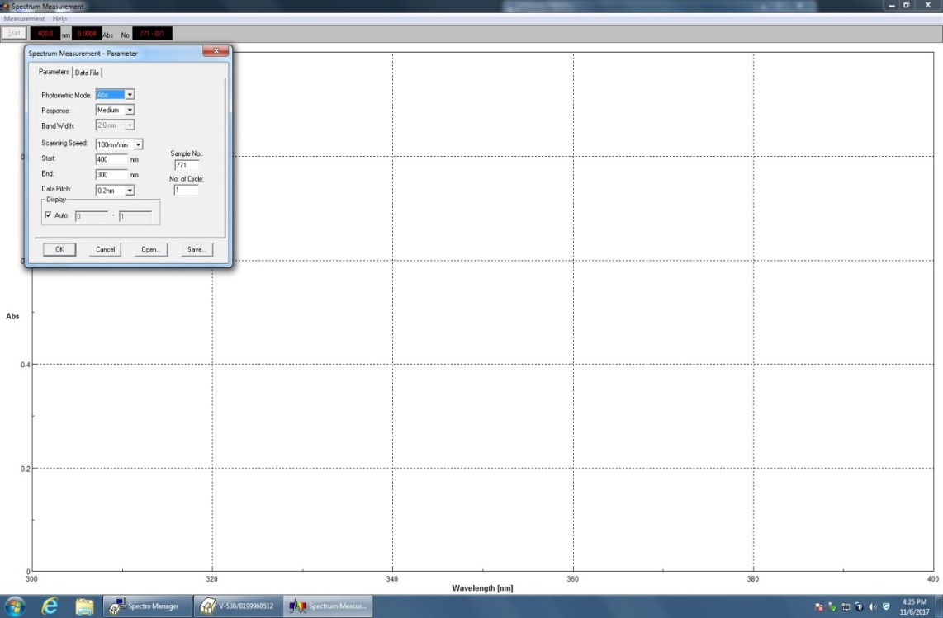
If you receive an error with your scan range, change the data pitch to 0.5 or 1 nm until it works.
Click OK.
Click on Measurement →Baseline
See that the baseline correction box is not checked. If it is, click on the box to uncheck it.
Click on Measure.
The instrument will scan the baseline spectrum and save the results in its memory to be subtracted automatically from the sample scans. The computer will prompt you for a baseline filename. Type in a name and click on OK. (If it will not let you type a name, delete some of the ones in the list to make room.)
A “Spectrum Analysis” window will open, or the icon will appear on the task bar at the bottom of the screen. You will be switching back and forth between those two windows. You will make scans in the “Spectrum Measurement” window and you will work with those scans in the “Spectrum Analysis” window.
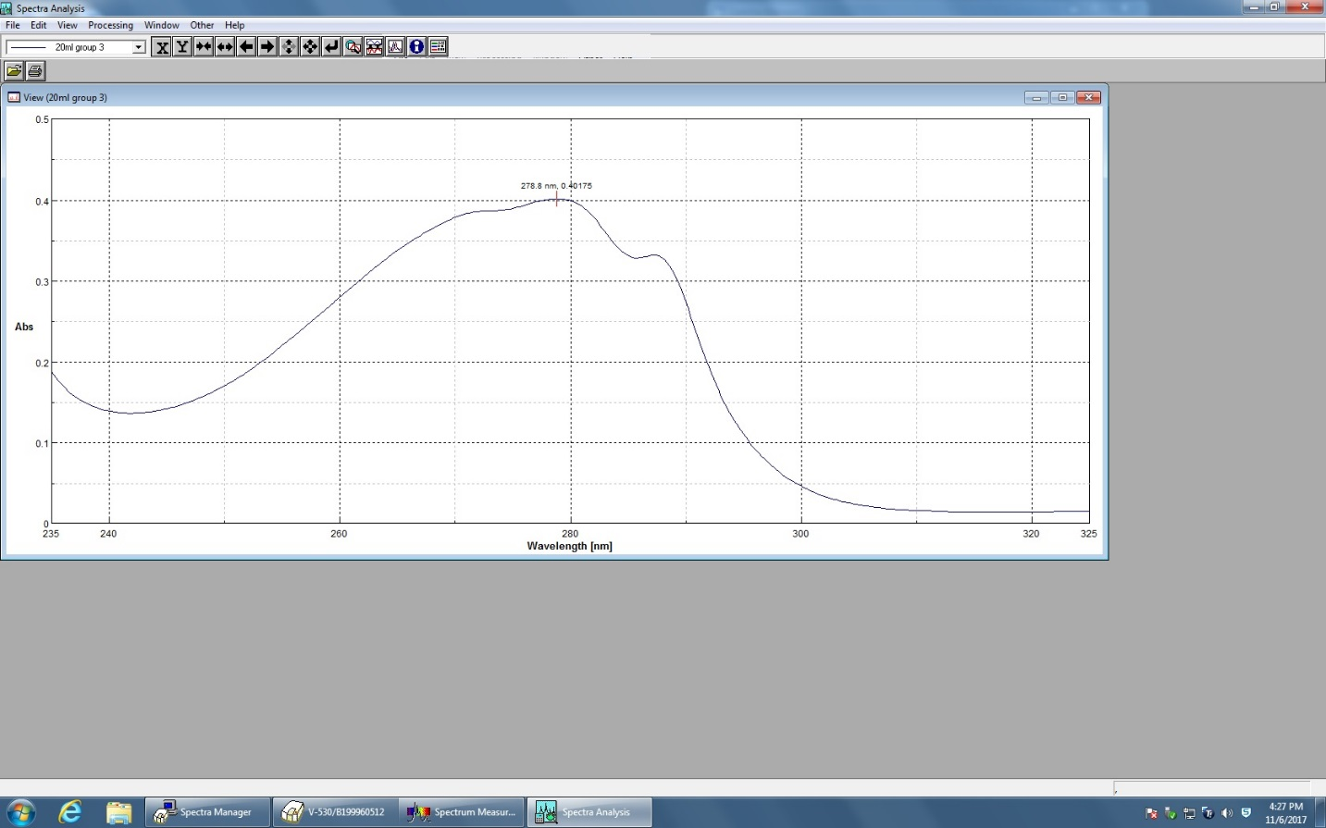

4. Measure sample spectrum
a. Replace the pure solvent in the sample cuvette (front) with your sample solution. Click Start. The spectrum will be scanned in the measurement window. When the scan is completed, click on the “Spectrum Analysis” icon. The spectrum will appear in a window labeled “Memory #2" if no other measurements have been made.
b. To label the wavelength and absorbance of the peaks, click on Processing → Peak Process → Peak Find. Click on Execute. Click OK. To show the peaks in the full view, click View → Peak → Bar, X,Y.
c. To save to the disk, Click on File → Save As. You can click on Comment to add a sample description that will be saved in the file and printed. Type in any comment, then type in the file name and save. Click on File → Print to print the spectrum. You should note all pertinent information in your notebook as well. The printout is not a substitute for a proper lab notebook!
d. Replace the sample with your next one (if you have one). Go to the measurement window and click Start to start a new scan. All scans will be saved in memory and added to the analysis window.

